Lab 1 - Getting Started with RISC-V (Assembly Language) in VS Code

Name: Aqsa Muneer, Maleeha Khan | Student ID:am10527, mk09991

Task 3:

Code:
li x20, 5 #a=5
li x18, 5 #just to store 5
li x19, 0
li x17, 32
add x21, x19, x19 #b = 0+0
add x20, x21, x17 #a=b+32
add x23, x20, x21 #newvar1=a+b
sub x24, x23, x18 #newvar2=newvar1-5 (=d)

sub x26, x20, x24 #newvar3=a-d
sub x27, x21, x20 #newvar4=b-a
add x28, x27, x26 #newvar5= newvar3+newvar4
add x29, x28, x24 # added d to newvar5
add x30, x20, x21 #nv=a+b
add x29, x29, x24 #nv2=d+e
add x29, x29, x30

Results:
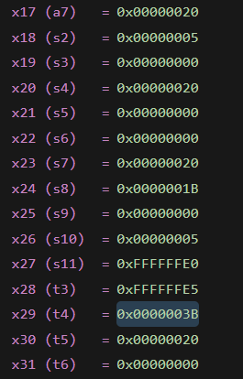

Task 4a:
- Store x10 as unsigned integer at address 0x100.
li x10, 0x78786464
li x11, 0xA8A81919
sw x10, 0x100(x0)
sw x11, 0x1F0 (x0)
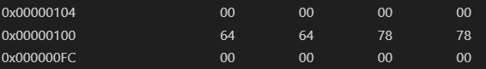

- Store x11 as unsigned integer at address 0x1F0.
li x10, 0x78786464
li x11, 0xA8A81919
sw x10, 0x100(x0)
sw x11, 0x1F0 (x0)
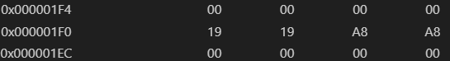

- Load an unsigned short integer (two bytes) from address 0x100 in x12.

li x5, 0x100 #temp reg
lhu x12, 0(x5)

- Load a short integer from address 0x1F0 in register x13.
li x6, 0x1F0
lh x13, 0(x6)

- Load a singed character from address 0x1F0 in register x14.
li x7, 0x1F0
lb x14, 0(x7)

Task 4b:

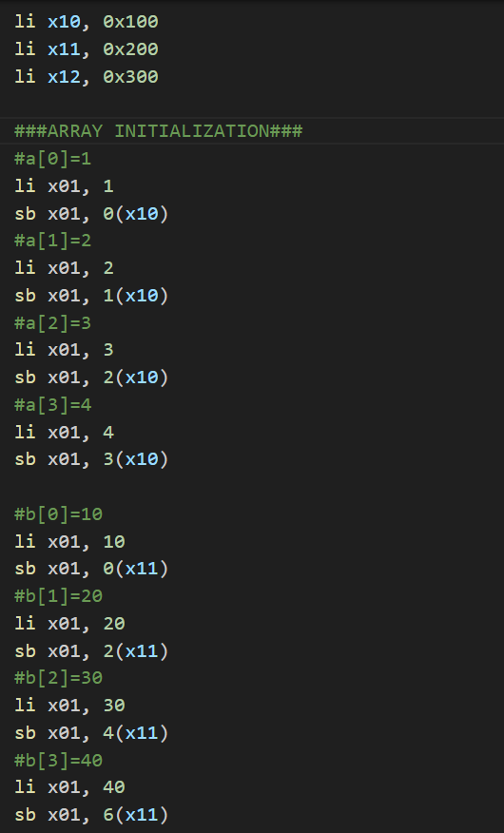
Code:
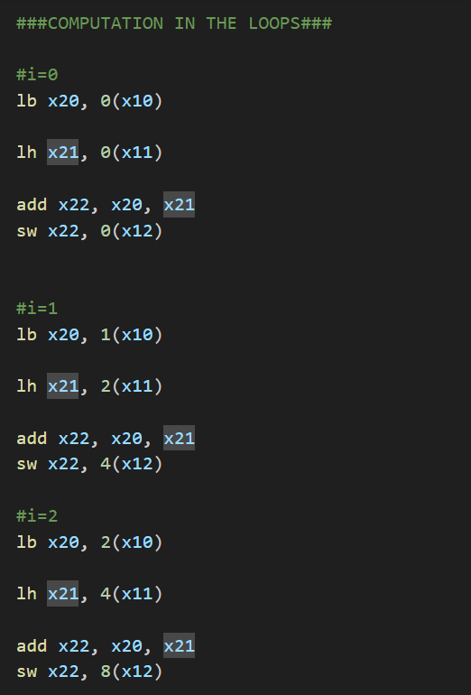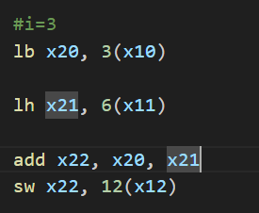

Results:
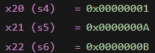
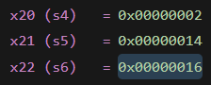
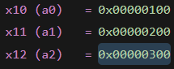
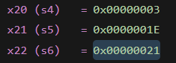

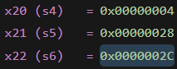
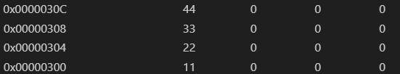

Assessment Rubric
Lab 1: Getting Started with RISC-V (Assembly Language) n VS Code

Name | Student ID: | Section:

Points Distribution:

 | Task No. | LR 2 (Code) | LR 5 (Results)
In-Lab | Task 1 | - | /15
 | Task 2 | - | /15
 | Task 3 | /10 | /5
 | Task 4a | /10 | /5
 | Task 4b | /10 | /10
Total Points: 100 |  | /30 | /50
CLO Mapped |  | CLO 2

Affective Domain Rubric |  | Points | CLO Mapped
AR7 | Report Submission & Git Upload | /10 & /10 | CLO 2

CLO | Total Points | Points Obtained
2 | 100
Total | 100

